**[Hosting a static website on Amazon S3](https://cognizant.tekstac.com/mod/tekcloud/view.php?id=94142)**

Step – 1 : click on Create an S3 bucket and give name starting with demo-……

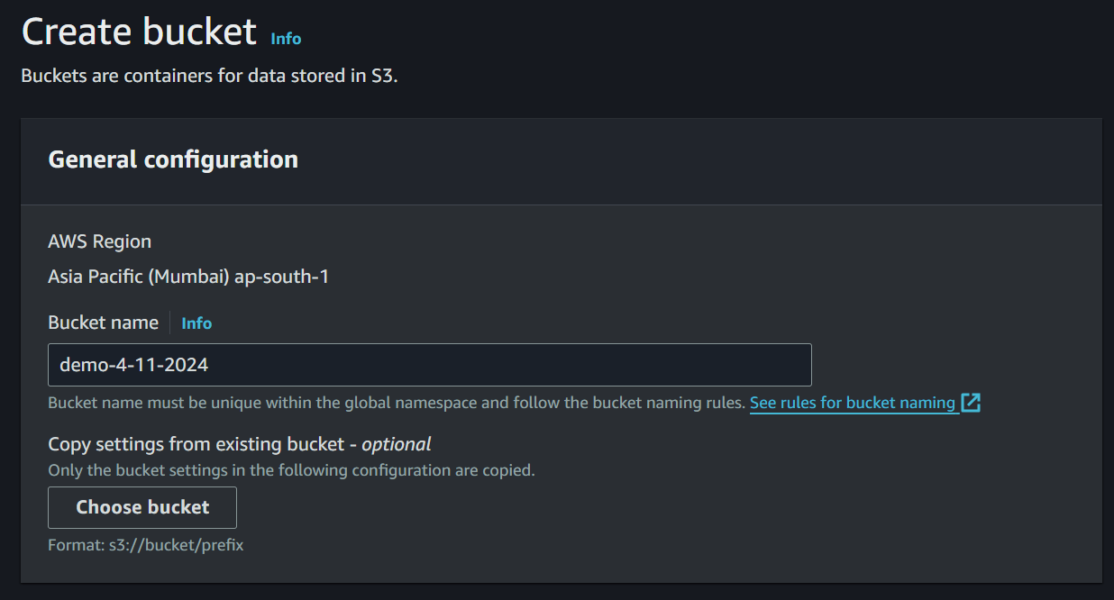

Step – 2 : Change the object ownership to ACLs enabled

Step – 3: Deselect the block public IP access and acknowledge it

Step – 4 : Enable bucket versioning

Step – 5 : Click on create bucket. After creating the bucket you will see your bucket listed in the buckets.

Step – 6 : Go to task description and click on the link to download the file and unzip the file.

Step – 7 : Now, upload the unzipped files into the S3 bucket.

Step – 9 : Click on enable, write the file names **index.html** and **error.html** in the 2 empty boxes and click on save changes.

**Step – 10 :** Go to bucket permissions, find bucket policy click on edit.

Step – 11 : Click on **policy generator** hyperlink. You will be redirected to this page.

Step – 12 : In the select type of policy click on S3 and then in the principal column write **\***, in the actions columns click on **Getobject** option and in the ARN column paste the bucket ARN(you will find in the bucket policy page).

and click on **add statement** option and then click on **generate policy.**

Step – 13 : Now copy this policy and then paste in the bucket policy and then click on save changes.

Step – 14 : Now, go to bucket properties and find the static website hosting and copy the website link.

Step – 15 : Now, paste this link in a browser, you will get the page like this.

Step – 16 : If you give the url incorrectly, then this error page will be loaded.

